|  |  |  |
| --- | --- | --- |
|  | | Marks |
| Athlete summary | 5 marks- names athlete, describes the sport and position of the athlete and the fitness requirements of that sport/position, level of sport played |  |
| 3 marks- names the athlete and describes the sport/position |  |
| 1 mark- names the athlete |  |
| Fitness Elements | 5 marks- states and describes the elements of fitness required |  |
| 3 marks- states the elements of fitness required |  |
| 1 mark- only states 1 or 2 elements of fitness required |  |
| 6 week program | 30 marks- Each week is detailed, varied and interesting.  There is evidence of progressive overload.  Training is targeted at fitness types detailed in part 2. |  |
| 15 marks- Each week is detailed.  Little evidence of progressive overload.  Training is partly targeted at fitness types detailed in part 2. |  |
| 0 marks- Not detailed.  No evidence of progressive overload.  Training is not specific to fitness types outlined in part 2. |  |
| Total | | /40 |

**Exercise Physiology Assessment**

**Athlete Training Program**

1. Choose an athlete from a sport of your choice. Give a brief summary of the sport your athlete is involved in. **(Short paragraph, 5 marks)**

2. State the component of fitness that are essential for your athlete, as well as others that may be beneficial. **(Short paragraph, 5 marks)**

3. Design a 6-week off-season training program targeted at improving the areas you have identified as important for your athlete. During the off-season training does not need to be targeted at skills specific to their sport, but must be specific to fitness requirements. **(Table, 30 marks)**

**Exercise Physiology Assessment**

**Athlete Training Program**

Athlete summary: Kobe Bryant, A now retried professional basketball player who was a shooting guard in the NBA (National Basketball Association) , who played 20 seasons for the los angles Lakers. Basketball is a sport that requires high athleticism, the player needs to be very fit to compete in the NBA. As a shooting guard, you need to be able to score many of the points, a shooting guard needs to be able to be agile enough to get to the ring or be quick enough to get a spot where they can pull of a jump shot.

Fitness Elements:

* Coordination:

A shooting guard in basketball will need to have coordination to control the ball and their movements with the ball so they don’t fall over or trip up. The definition of coordination is the ability to use different parts of the body together smoothly and efficiently. Coordination is also important for coordinating your shot, and feet when going for a layup or a dunk.

* Muscular strength:

Muscular strength is defined as the maximum amount of force that a muscle can exert against some form of resistance in a single effort. This is important for any basketball player, as they will need to be able to exert lots of force in a jump to perform certain moves, like a dunk, rebound or even a shot from the 3-point line. The shooting guard position requires all of this, with the addition of needing to be able to boost off a stationary position to beat the defense.

* Muscular Endurance:

Muscular endurance is the ability of a muscle or group of muscles to sustain repeated contractions against a resistance for an extended period. Muscular endurance is important for any position in basketball as they all need to be able to use their muscles to create lots of force for a long period of time and repeatedly, whether is be bouncing the ball, running or shooting.

* Agility:

Agility is the ability to move quickly and easily. For a shooting guard this important for them to be able to get into the key and close to the ring, as they are not always the biggest dudes on the court.

* Speed:

speed is the rate at which someone or something moves or operates or can move or operate. This is a large factor in whether a shooting guard is good, as they use their speed to get past most opposition, Kobe is one of these players as he was very quick.

* Power:

Power is the ability to exert a maximal force in as short a time as possible, as in accelerating, jumping and throwing implements. This will be important for a dunk or a quick layup, or jump shot which are special moves of a shooting guard and Kobe.

* Cardiorespiratory Endurance:

cardiorespiratory endurance is the ability of heart and lungs to absorb, transport and utilize oxygen over extended period during physical exertion. In basketball a player will run up and down the court multiple times in one game, so for a player to play at the same level throughout the game they need to have good endurance and lungs.

6 Week program:

|  |  |  |  |  |  |  |
| --- | --- | --- | --- | --- | --- | --- |
|  | Week 1 | Week 2 | Week 3 | Week 4 | Week 5 | Week 6 |
| Mon | 5km run, time limit 18mins. Then skill practice in gym (basketball court facility) . | 5km run, time limit 13mins. Then skills practice in gym. | 2x 5km run, with 10 min break period in-between run. Time period for each run 15mins. Then skill practice in gym. | 4x 2.5km runs, 5min break in-between runs. Time limit for each is 7mins. Then skill practice in gym. | 6x 2.5km  Run with 5 min break in-between run and time limit of 7mins. Then skill practice in gym. | 6x 2.5km run with 5min break in-between run, time limit for each run 5mins.  Then skill practice in gym. |
| Tue | Full body Circuit training: circuit will be:   * 10mins of squat jumps. * 5mins break * 10 reps of burpees * 5mins break * 10mins of skipping * 5mins break * 10 Reps of Squat to presses | Full body Circuit training: circuit will be:   * 15mins of squat jumps. * 5mins break * 15 reps of burpees * 5mins break * 15mins of skipping * 5mins break * 15 Reps of Squat to presses | Full body Circuit training: circuit will be:   * 15mins of squat jumps. * 3mins break * 15 reps of burpees * 3mins break * 15mins of skipping * 3mins break * 15 Reps of Squat to presses | Full body Circuit training: circuit will be:   * 18mins of squat jumps. * 3mins break * 18 reps of burpees * 3mins break * 18mins of skipping * 3mins break * 18 Reps of Squat to presses | Full body Circuit training: circuit will be:   * 20mins of squat jumps. * 3mins break * 20 reps of burpees * 3mins break * 20mins of skipping * 3mins break * 20 Reps of Squat to presses | Full body Circuit training: circuit will be:   * 20mins of squat jumps. * 1min break * 20 reps of burpees * 1min break * 20mins of skipping * 1min break * 20 Reps of Squat to presses |
| Wed | * Warm-up: 10-15 minutes of mobility exercises, 5-10 minutes of ankle exercises * [Split-Squats](https://www.stack.com/a/dumbbell-split-squat) – 10 reps each leg * Partial [Deadlifts](https://www.stack.com/a/deadlift-variations) (bar at knee height) – 10 reps * [Glute Ham Raises](http://www.stack.com/video/96634358001/Glute-Ham-Raise/) – 10 reps * Physio ball Leg Curls – 10 reps * Eccentric calf raises- 10 reps | * Warm-up: 10-15 minutes of mobility exercises, 5-10 minutes of ankle exercises * [Split-Squats](https://www.stack.com/a/dumbbell-split-squat) – 12 reps each leg * Partial [Deadlifts](https://www.stack.com/a/deadlift-variations) (bar at knee height) – 12 reps * [Glute Ham Raises](http://www.stack.com/video/96634358001/Glute-Ham-Raise/) – 12 reps * Physio ball Leg Curls – 12 reps * Eccentric calf raises- 12 reps | * Warm-up: 10-15 minutes of mobility exercises, 5-10 minutes of ankle exercises * [Split-Squats](https://www.stack.com/a/dumbbell-split-squat) – 14 reps each leg * Partial [Deadlifts](https://www.stack.com/a/deadlift-variations) (bar at knee height) – 14 reps * [Glute Ham Raises](http://www.stack.com/video/96634358001/Glute-Ham-Raise/) – 14 reps * Physio ball Leg Curls – 14 reps * Eccentric calf raises- 14 reps | * Warm-up: 10-15 minutes of mobility exercises, 5-10 minutes of ankle exercises * [Split-Squats](https://www.stack.com/a/dumbbell-split-squat) – 16 reps each leg * Partial [Deadlifts](https://www.stack.com/a/deadlift-variations) (bar at knee height) – 16 reps * [Glute Ham Raises](http://www.stack.com/video/96634358001/Glute-Ham-Raise/) – 16 reps * Physio ball Leg Curls – 16 reps * Eccentric calf raises- 16 reps | * Warm-up: 10-15 minutes of mobility exercises, 5-10 minutes of ankle exercises * [Split-Squats](https://www.stack.com/a/dumbbell-split-squat) – 18 reps each leg * Partial [Deadlifts](https://www.stack.com/a/deadlift-variations) (bar at knee height) – 18 reps * [Glute Ham Raises](http://www.stack.com/video/96634358001/Glute-Ham-Raise/) – 18 reps * Physio ball Leg Curls – 18 reps * Eccentric calf raises- 18 reps | * Warm-up: 10-15 minutes of mobility exercises, 5-10 minutes of ankle exercises * [Split-Squats](https://www.stack.com/a/dumbbell-split-squat) – 20 reps each leg * Partial [Deadlifts](https://www.stack.com/a/deadlift-variations) (bar at knee height) – 20 reps * [Glute Ham Raises](http://www.stack.com/video/96634358001/Glute-Ham-Raise/) – 20 reps * Physio ball Leg Curls – 20 reps * Eccentric calf raises- 20 reps |
| Thur | Rest day | Rest day | Rest Day | Rest day | Rest day | Rest day |
| Fri | Upper body circuit training.:   * Bicep curls 2x10 reps * Pushups 2x10 reps * Diamond pushups 2x10 reps * Plyometric pushups 2x10 reps * Bench dips2x 10 reps | Upper body circuit training.:   * Bicep curls 2x12 reps * Pushups 2x12 reps * Diamond pushups 2x12 reps * Plyometric pushups 2x12 reps * Bench dips 2x12 reps | Upper body circuit training.:   * Bicep curls 2x14 reps * Pushups 2x14 reps * Diamond pushups 2x14 reps * Plyometric pushups 2x14 reps * Bench dips2x14 reps | Upper body circuit training.:   * Bicep curls 2x16 reps * Pushups 2x16 reps * Diamond pushups 2x16 reps * Plyometric pushups 2x16 reps * Bench dips2x16 reps | Upper body circuit training.:   * Bicep curls 2x18 reps * Pushups 2x18 reps * Diamond pushups 2x18 reps * Plyometric pushups 2x18 reps * Bench dips 2x18 reps | Upper body circuit training.:   * Bicep curls 2x20 reps * Pushups 2x20 reps * Diamond pushups 2x20 reps * Plyometric pushups 2x20 reps * Bench dips 2x20 reps |
| Sat | Lower body circuit training:   * One leg squat 2x10 reps * Single leg kickbacks 2x10 reps * Forward lunges 2x10 reps * Box step with knee drive 2x10 reps. | Lower body circuit training:   * One leg squat 2x12 reps * Single leg kickbacks 2x12 reps * Forward lunges 2x12 reps * Box step with knee drive 2x12 reps. | Lower body circuit training:   * One leg squat 2x14 reps * Single leg kickbacks 2x14 reps * Forward lunges 2x14 reps * Box step with knee drive 2x14 reps. | Lower body circuit training:   * One leg squat 2x16 reps * Single leg kickbacks 2x16 reps * Forward lunges 2x16 reps * Box step with knee drive 2x16 reps. | Lower body circuit training:   * One leg squat 2x18 reps * Single leg kickbacks 2x18 reps * Forward lunges 2x18 reps * Box step with knee drive 2x18 reps. | Lower body circuit training:   * One leg squat 2x20 reps * Single leg kickbacks 2x20 reps * Forward lunges 2x20 reps * Box step with knee drive 2x20 reps. |
| Sun | Rest day | Rest day | Rest day | Rest day | Rest day | Rest day |

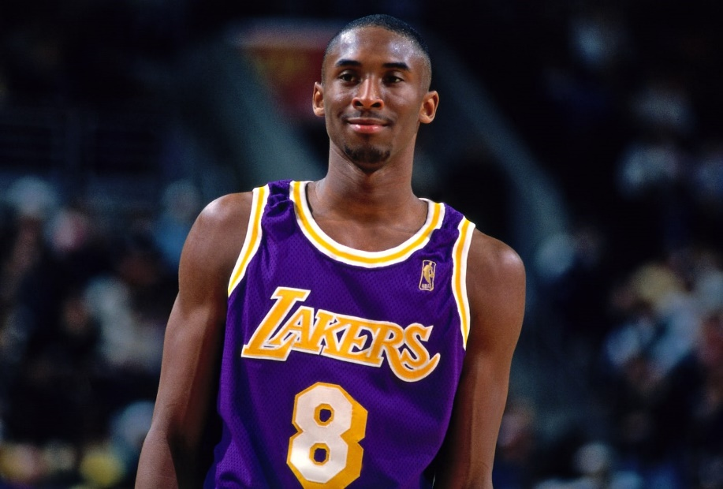



[Document title]

[Document subtitle]

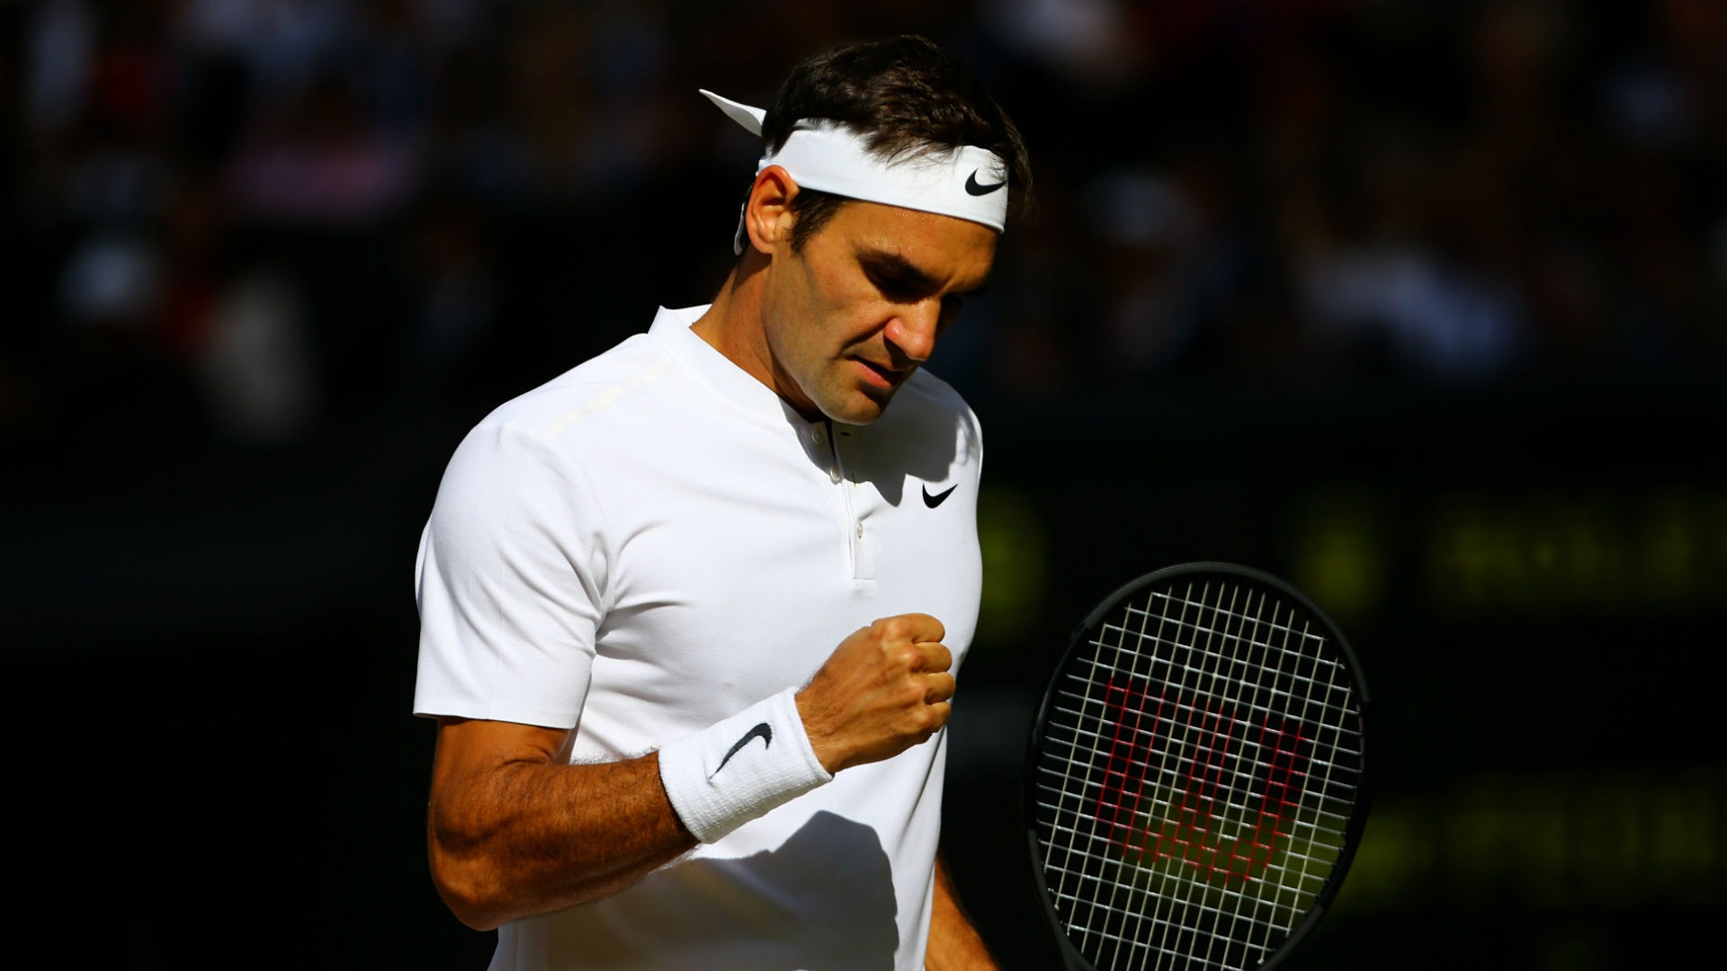

|  |  |  |  |  |  |  |  |
| --- | --- | --- | --- | --- | --- | --- | --- |
|  | Monday | Tuesday | Wednesday | Thursday | Friday | Saturday | Sunday |
| Week 1 | Leg day | Core day | Game practice | Arm day | Play badminton | Rest day | Swimming |
| Week 2 | Core day | Game practice | Arm day | Swimming | Rest day | Leg day | Play squash |
| Week 3 | Game practice | Arm day | Leg day | Rest day | core day | Play badminton | Game practice |
| Week 4 | Swimming | Leg day | Rest day | Play squash | Swimming | Game practice | Arm day |
| Week 5 | Play badminton | Rest day | Game practice | Leg day | Game practice | core day | Arm day |
| Week 6 | Rest day | Game practice | Core day | Rest day | Play squash | Leg day | Game practice |

**Off-season training program for tennis**

**Leg day :**

Leg exercises can help build the muscles your legs. In tennis legs are an important part and training for them is a constant. They ensure balance to push yourself and g to the other side of the court and well as give you the power to last a whole game. Exercises you can do are

* **Leg presses (3x10) –** stimulates quads, glutes and hamstrings
* **Partial squat (4x10)-**improve strength in quadriceps and hips
* **Calf raises (2x15**)- building up the gastrocnemius and soleus muscles**.**
* **Elastic band kicks (4x12**)- will strengthen medial glutes and hi abductors and help prevent knee injuries.
* **Bulgarian split squat(3x15) –** quadriceps and maximise glutes
* 2k run

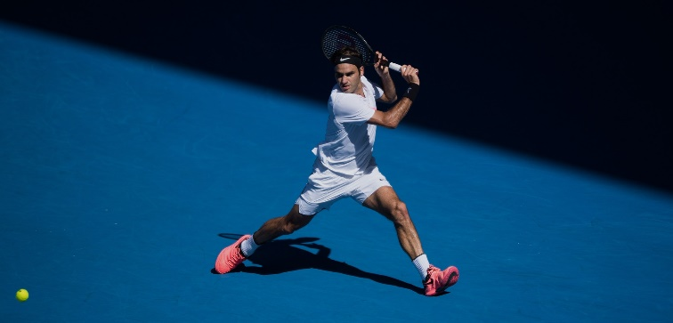

**Core day:**

* **Curl ups (3x20)-** strengthen abdominals
* **Forearm plank 2 minutes or more (3 times)-** strengthens abdominals and lower back
* **Reverse crunch (13-20 reps)-** works abdominals and obliques
* **Plank with arm and leg lifted (hold for 1 to 2 sec the switch sides 20 reps)-** works shoulders, triceps, abs, hamstrings and glutes
* **Side plank (1 minute each side**)
* **Bicycle (start 20 reps and work your way up to 100)-** calves, hamstrings, core, back and glutes
* **Windshield wiper (20 reps**)- increases stability and core strength.
* **Medicine ball toss (reps 20) – (**your abs partner in crime), strengthens your hamstrings, adductors and abdominals

**Arm day:**

* **Biceps curl (3x10**) – strengthens biceps
* **Shoulder workouts: shrug, prone fly and shoulder punch (2x15)** – improves biceps n shoulder muscles
* **Forearm and wrist workout: wrist flexion and extension curls with dung bells, radial and ulnar deviation with dung bells and pronation and supination with dung bells (2x15)-** increases forearm muscles
* **Triceps extensions with dung bells (3x15)**- isolation exercise that strengthens your triceps muscles
* **Bench presses(2x10)-** developing upper body strength such as chest, front shoulders and latissimus Doris.
* **T-raise with dung bells (2x10)-**increased shoulder mobility and upper back
* **Side plank with lateral raise with dung bells (2x10**)- helps tone obliques and legs from heel to hip

**Swimming:**

Swimming is a really good resistance exercise, it can impact a tennis player’s arms and legs and recovery of injuries from any previous training during the week.

* **1k swim**- can develop endurance and is a great way to develop stamina and improve cardiovascular health, which is crucial for tennis players.
* **Light swimming (breathe stroke backward stroke and freestyle)-** can put less pressure on the bones, muscles and joints.
* Swimming also increase your flexibility and it is essential as a tennis player to be flexible and help decrease risk of injuries.
* **50m sprint training-** can build up power to hit the ball when playing a game.

**Badminton game/ squash:**

* When a tennis player is on off season it would get bored playing tennis all the time so occasionally playing other sports similar to tennis would be good for them such as badminton. Badminton would be good for my specific athlete because:
* It works on his endurance and muscle memory going from one side of the court to the other like you do in all these three sports (badminton, tennis and squash.)
* It will improve their fitness and footwork
* it will improve their speed/agility when going for the ball in squash off the wall and in badminton when a player has smashed the shuttlecock on the opposite side of the court.
* It increases muscular endurance playing the sport for a long period of time.
* Badminton helps with wrist but squash helps with reaction time.

**Tennis game:**

* When the player is on their off season it is important is occasionally play a tennis game to keep up with their muscular endurance and speed/agility, power and flexibility.
* It is important to have these components in a game and when working out during the week on individual body parts, playing a game will put all those body parts that the athlete has been working on into motion.

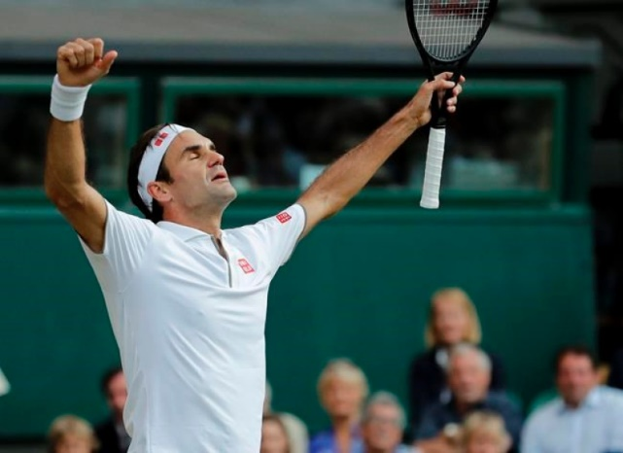

**Sport; Tennis**

**Athlete summary: Roger Federer**

The sport I have chosen is tennis, tennis is a racket sport that can be played individually against a single opponent (this is called singles) or between two teams or two players each (this is doubles). Each players uses a tennis racket and the purpose is for your tennis racket to hit a hollow rubber ball covered with felt over or around a net and into the opponent’s court. The object of the game is to manoeuvre the ball in such a way that the opponent is not able to play a valid return. The fitness required for this sport is a high level of stamina and cardio endurance, also physically fit and strong. A tennis athlete requires many physical requirements, such as aerobics fitness, strength, good co-ordination, good flexibility and good mental ability.

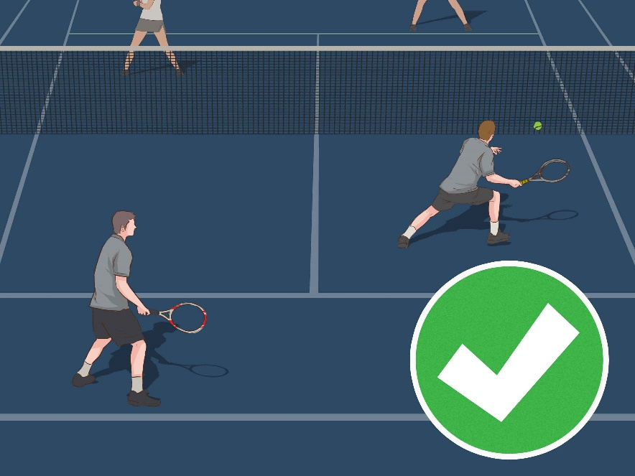

**Components of Fitness:**

Tennis is one of those unique sports that have a combination of nearly all the components of fitness these are some of the components of fitness used in tennis:

**Power**- you can use power in tennis in the serving motion and overhead smashes. you can train for power by doing: power cleans, box jumps and lateral plyometric jumps.

**Agility/speed**- covering the full court and the ability to move the body in all planes of movement. you can train for agility/speed by: ladder drills, cone drills and power band running.

**Flexibility-** by having a good range of movement is vital for tennis. Things that can improve your flexibility is: yoga, set time aside pre and post training and sessions per week to focus on ur flexibility.

**Muscular endurance-** long-term plan for a tennis player and builds up over time. Also helps running side to side during a game, makes them last a full game as you cannot sub for tennis so player needs to last a whole game. You can train for this by: running for a long duration of time and having a balanced diet.

